Lab 6 Voltage Multipliers II

**Date: Reg.#:**

## OBJECTIVES:

## To study the application of a diode as a voltage tripler and quadrupler respectively.

## EQUIPMENT AND COMPONENTS:

* Basic Circuits Training Board
* 1N4007 Rectifier Diode
* Jumper Wires
* Scope / DMM
* Resistors
* Electrolyte Capacitors
* Voltage Transformer

---------------------------------------------------------------------------------------------------------------------

In this lab voltage multipliers are now extended to obtain higher voltage levels:

* Voltage Tripler
* Voltage quadrupler

## Voltage Tripler:

The voltage tripler can be obtained by adding one more diode-capacitor stage to the half-wave voltage doubler circuit.

**During first positive half cycle:**

During the first positive half cycle of the input AC signal, the diode D1 is forward biased whereas diode D2 is reverse biased. Hence, the diode D1 allows electric current through it. This current will flow through the capacitor C1 and charges it to the peak value of the input voltage i.e. Vm.

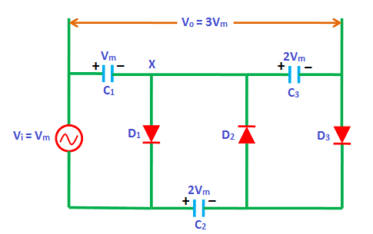

Fig: Voltage Tripler

**During negative half cycle:**

During the negative half cycle, diode D2 is forward biased whereas diodes D1 and D3 are reverse biased. Hence, the diode D2 allows electric current through it. This current will flow through the capacitor C2 and charges it. The capacitor C2 is charged to twice the peak voltage of the input signal (2Vm). This is because the charge (Vm) stored in the capacitor C1 is discharged during the negative half cycle.

Therefore, the capacitor C1 voltage (Vm) and the input voltage (Vm) is added to the capacitor C2 i.e. capacitor voltage + input voltage = Vm + Vm = 2Vm. As a result, the capacitor C2 charges to 2Vm.

**During second positive half cycle:**

During the second positive half cycle, the diode D3 is forward biased whereas diodes D1 and D2 are reverse biased. Diode D1 is reverse biased because the voltage at X is negative due to charged voltage Vm, across C1 and diode D2 is reverse biased because of its orientation. As a result, the voltage (2Vm) across capacitor C2 is discharged. This charge will flow to the capacitor C3 and charges it to the same voltage 2Vm.

The capacitors C1 and C3 are in series and the output voltage is taken across the two series connected capacitors C1 and C3. The voltage across capacitor C1 is Vm and capacitor C3 is 2Vm. So the total output voltage is equal to the sum of capacitor C1 voltage and capacitor C3 voltage i.e. C1 + C3 = Vm + 2Vm = 3Vm.

Therefore, the total output voltage obtained in voltage tripler is 3Vm which is three times more than the applied input voltage.

## Voltage Quadrupler:

The voltage quadrupler can be obtained by adding one more diode-capacitor stage to the voltage tripler circuit.

The operation of the circuit during the first and second positive cycle and negative cycle has already been explained which also applies to the voltage quadrupler. Here it is necessary to understand the operation of the circuit during the second negative cycle which is explained below.

**During second negative half cycle:**

During the second negative half cycle, diodes D2 and D4 are forward biased whereas diodes D1 and D3 are reverse biased. As a result, the charge (2Vm) stored in the capacitor C3 is discharged. This charge will flow to the capacitor C4 and charges it to the same voltage (2Vm).

The capacitors C2 and C4 are in series and the output voltage is taken across the two series connected capacitors C2 and C4. The voltage across capacitor C2 is 2Vm and capacitor C4 is 2Vm. So the total output voltage is equal to the sum of capacitor C2 voltage and capacitor C4 voltage i.e. C2 + C4 = 2Vm + 2Vm = 4Vm.

Therefore, the total output voltage obtained in voltage quadrupler is 4Vm which is four times more than the applied input voltage.

.

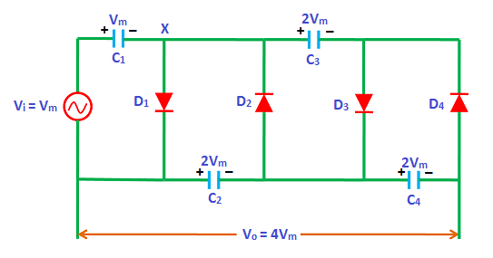

Fig: Voltage Quadrupler

## Observations:

**Frequency = __________ , Capacitance = __________**

|  |  |  |  |  |
| --- | --- | --- | --- | --- |
| **Input Signal Amplitude** | **Voltage between C1 and input** | **Voltage between C2 and input** | **Voltage between C3 and input** | **Voltage between C4 and input** |
|  |  |  |  |  |
|  |  |  |  |  |
|  |  |  |  |  |
|  |  |  |  |  |
|  |  |  |  |  |

# REVIEW QUESTIONS:

Q: What should be the least PIV rating of each diode and why?

Q: How many diodes and capacitors would be required to implement voltage hexrupler?